In-house Workshop Report On

##### WEB DEVELOPMENT

submitted in partial fulfillment of the requirement for the degree of Bachelor of Technology

In Computer Science

by

###### ISHAN ARORA– 51555102717



Mahavir Swami Institute of Technology (Affiliated to Guru Gobind Singh Indraprastha University)

Jagdishpur, Sonipat – 131030 November – 2019

### TABLE OF CONTENTS

* Attestation of Authorship
* Acknowledgement
* Abstract
* Chapter1-Introduction
  + Web development
  + Front-end and Back-end
* Chapter 2 – Pre Requisite Knowledge
  + HTML
  + CSS
  + JAVASCRIPT
  + Jquery
  + BOOTSTRAP
* Chapter 3 – Work Details
* Chapter 4 – Step wise working for website
* Outputs
* Conclusion
* References

#### ATTESTATION OF AUTHORSHIP

I hereby declare that this Submission for partial fulfillment of the requirements for the degree of B. Tech. course is my own work and that to the best of my knowledge and belief,

It contains no written material which to a substantial extent has been accepted for the qualification of any other degree or diploma of a university or other institution of higher learning except where due acknowledge is made.

Name of the student : ISHAN ARORA

Roll No.

51555102717

Branch & Semester B.Tech (CSE) 5th Sem

#### ACKNOWLEDGEMENT

I have taken efforts in this project. However, it would not have been possible without the kind support and help of many individuals and organizations. I would like to extend my sincere thanks to all of them.

I almighty indebted to Mahavir Swami Institute of Technology And Management for its guidance and constant supervision as well as for providing necessary information regarding the project & also for its support in completing the project.

We wish to express our sincere gratitude to Ms.Shruti Ahuja, Computer Science Department who introduced the training and gave an opportunity to start this project.

We sincerely thank Mr.sunil, APTECH INTERNATIONAL our trainer for his guidance and encouragement in carrying out the project work. I also wish to express my gratitude to other staff and members of Coding Blocks who rendered their help in this project work.

##### ABSTRACT

In this project we respresent a website of Restaurant BRESCA DC. The website is made for showing the customers :

* Timings of restaurant
* Menu of restaurant
* Facilities of restaurant
* Stay in hotel
* Online bookings at restaurant
* Private dining registration at restaurant
* Special day cusines at restaurant
* Awards to restaurant

**The website is also made for the promotion for restaurant which is done through digital marketing of website.**

### CHAPTER 1

**INTRODUCTION**

* 1. ***WEB DEVELOPMENT***

There are two broad divisions of web development – front-end development (also called client-side development) and back-end development (also called server-side development).

Front-end development refers to constructing what a user sees when they load a web application – the content, design and how you interact with it. This is done with three codes – HTML, CSS and JavaScript.

HTML, short for Hyper Text Markup Language, is a special code for ‘marking up’ text in order to turn it into a web page. Every web page on the net is written in HTML, and it will form the backbone of any web application. CSS, short for Cascading Style Sheets, is a code for setting style rules for the appearance of web pages. CSS handles the cosmetic side of the web. Finally, JavaScript is a scripting language that’s widely used to add functionality and interactivity to web pages.

Back-end development controls what goes on behind the scenes of a web application. A back-end often uses a database to generate the front-end.

Here’s an example. Say you log into your Facebook account, and you are greeted with the latest updates in your News Feed. They’re not going to be the same updates that you saw yesterday.

How did the page change? Did a Facebook employee manually edit the page to update your news feed? Of course not. A script on the Facebook back-end would have received the updates and re-generated the front-end accordingly.

Back-end scripts are written in many different coding languages and frameworks, such as…

* PHP
* Ruby on Rails
* ASP.NET
* Perl
* Java
* Node.js
* Python
  1. ***FRONT END DEVELOPING***

Front-end web development, also known as client-side development is the practice of producing HTML, CSS and JavaScript for a website or Web Application so that a user can see and interact with them directly. The challenge associated with front end development is that the tools and techniques used to create the front end of a website change constantly and so the developer needs to constantly be aware of how the field is developing.

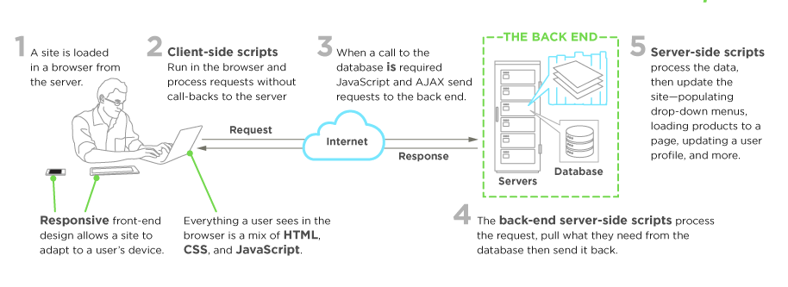

The objective of designing a site is to ensure that when the users open up the site they see the information in a format that is easy to read and relevant. This is further complicated by the fact that users now use a large variety of devices with varying screen sizes and resolutions thus forcing the designer to take into consideration these aspects when designing the site. They need to ensure that their site comes up correctly in different browsers (cross-browser), different operating systems (cross-platform) and different devices (cross-device), which requires careful planning on the side of the developer.

A front-end developer architects and develops websites and applications using web technologies (i.e., HTML, CSS, DOM, and JavaScript), which run on the Open Web Platform or act as compilation input for non-web platform environments

* 1. ***BACK END DEVELOPING***

Back-end Development refers to the server-side development. It is the term used for the behind-the-scenes activities that happen when performing any action on a website. It can be logging in to your account or purchasing a watch from an online store.

Backend developer focuses on databases, scripting, and the architecture of websites. Code written by back-end developers helps to communicate the database information to the browser.

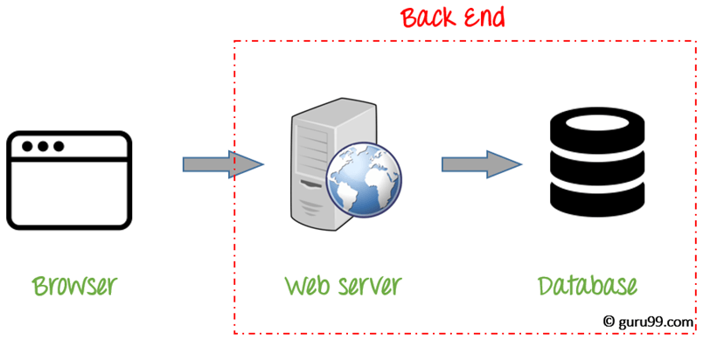

Most common example of Backend programming is when you are reading an article on the blog. The fonts, colors, designs, etc. constitute the frontend of this page. While the content of the article is rendered from a server and fetched from a database. This is the backend part of the application.

***1.3.1 Skill sets required to become a Backend Developer***

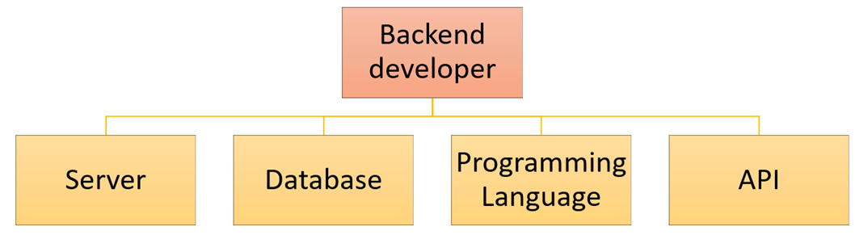

A backend developer works with the following

* Web Development Languages
* Database and cache
* Server
* API (REST & SOAP)
* Development Languages

Backend engineer should know at least one server-side programming languages like Java, Python, Ruby, . Net etc.

**Database and cache**

Knowledge of various DBMS technology is another important need of backend developer. MySQL, MongoDB, Oracle, SQL Server, Redis are widely used for this purpose. Knowledge of caching mechanisms like varnish, Memcached, Redis is a plus.

**Server**

Exposure to handling Apache, Nginx, IIS servers, Microsoft IIS is desirable. A good background in Linux helps tremendously in administering servers.

**API (REST & SOAP):**

Knowledge of web services or API is also important for full stack developers. Knowledge of creations and consumption of REST and SOAP services is desirable.

* 1. ***JAVA DATABASE CONNECTIVITY***

JDBC is an acronym for Java Database Connectivity. It’s an advancement for ODBC ( Open Database Connectivity ). JDBC is an standard API specification developed in order to move data from frontend to backend. This API consists of classes and interfaces written in Java. It basically acts as an interface (not the one we use in Java) or channel between your Java program and databases i.e it establishes a link between the two so that a programmer could send data from Java code and store it in the database for future use.

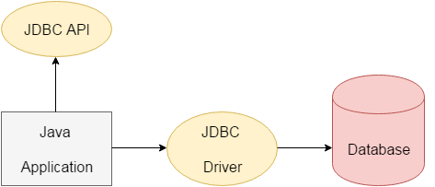

JDBC is an advancement for ODBC, ODBC being platform dependent had a lot of drawbacks. ODBC API was written in C,C++, Python, Core Java and as we know above languages (except Java and some part of Python )are platform dependent . Therefore to remove dependence, JDBC was developed by database vendor which consisted of classes and interfaces written in Java.

* + 1. ***APPLICATIONS OF JDBC***

Fundamentally, JDBC is a specification that provides a complete set of interfaces that allows for portable access to an underlying database. Java can be used to write different types of executables, such as −

* Java Applications
* Java Applets
* Java Servlets
* Java ServerPages (JSPs)
* Enterprise JavaBeans (EJBs).

All of these different executables are able to use a JDBC driver to access a database, and take advantage of the stored data.

JDBC provides the same capabilities as ODBC, allowing Java programs to contain database-independent code.

* + 1. ***JDBC ARCHITECTURE***

JDBC is designed to make Java applications database agnostic. That is, a program written using JDBC will work with any JDBC compliant database. That was a Java application that is tested with Apache Derby can confidently be deployed against an IBM DB2 database in production. However, there are differences between database vendors, and these differences must be abstracted away. The tool for abstracting away these differences is known as a JDBC driver.

When a Java wants to connect to a database, it calls upon a JDBC interface known as the DriverManager, which loads a driver that has been written specifically by the vendor of the database to which the Java program is connecting. This driver contains all of the information required to connect the Java program to the underlying database. The JDBC driver is vendor specific, so the MySQL JDBC driver is different from the Apache Derby JDBC driver. The job of these drivers is to address differences between databases at the technical level, abstract them away from the application, and allow Java developers to be confidence that the JDBC API they interact with will work with any JDBC compliant database.

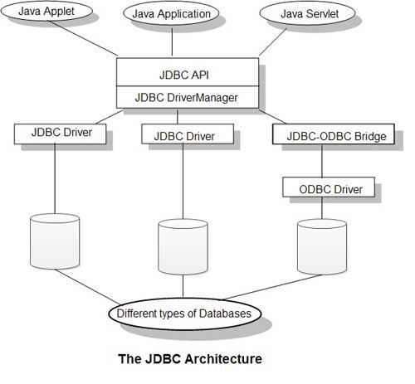

* + 1. ***TYPES OF JDBC DRIVERS***

The JDBC-ODBC bridge is referred to as the Type 1 JDBC driver. There are four types, with the distinctions being:

1. The Type 4 JDBC driver is written purely in Java and works over a network connection. This is often referred to as the JDBC thin driver.
2. The Type 3 JDBC driver which first interacts with a middleware server such as IBM WebSphere, which then in turn communicates with the relational database. This is sometimes referred to as the JDBC proxy driver.
3. The Type 2 JDBC driver which may or may not be written in Java. These drivers typically include proprietary code written specifically for a given database to optimize performance and throughput. This driver is often referred to as the thick JDBC driver.
4. The Type 1 JDBC driver is the aforementioned JDBC-ODBC bridge.

### CHAPTER 2

PREREQUISITE KNOWLEDGE

* 1. HTML

**Hypertext Markup Language** (**HTML**) is the standard [markup language](https://en.wikipedia.org/wiki/Markup_language" \o "Markup language) for documents designed to be displayed in a [web browser](https://en.wikipedia.org/wiki/Web_browser). It can be assisted by technologies such as [Cascading Style Sheets](https://en.wikipedia.org/wiki/Cascading_Style_Sheets) (CSS) and [scripting languages](https://en.wikipedia.org/wiki/Scripting_language) such as [JavaScript](https://en.wikipedia.org/wiki/JavaScript).

[Web browsers](https://en.wikipedia.org/wiki/Web_browser) receive HTML documents from a [web server](https://en.wikipedia.org/wiki/Web_server) or from local storage and [render](https://en.wikipedia.org/wiki/Browser_engine) the documents into multimedia web pages. HTML describes the structure of a web page [semantically](https://en.wikipedia.org/wiki/Semantic_Web) and originally included cues for the appearance of the document.

[HTML elements](https://en.wikipedia.org/wiki/HTML_element) are the building blocks of HTML pages. With HTML constructs, [images](https://en.wikipedia.org/wiki/HTML_element#Images_and_objects) and other objects such as [interactive forms](https://en.wikipedia.org/wiki/Fieldset) may be embedded into the rendered page. HTML provides a means to create [structured documents](https://en.wikipedia.org/wiki/Structured_document) by denoting structural [semantics](https://en.wikipedia.org/wiki/Semantics) for text such as headings, paragraphs, lists, [links](https://en.wikipedia.org/wiki/Hyperlink), quotes and other items. HTML elements are delineated by *tags*, written using [angle brackets](https://en.wikipedia.org/wiki/Bracket#Angle_brackets). Tags such as <**img** /> and <**input** /> directly introduce content into the page. Other tags such as <**p**> surround and provide information about document text and may include other tags as sub-elements. Browsers do not display the HTML tags, but use them to interpret the content of the page.

HTML can embed programs written in a [scripting language](https://en.wikipedia.org/wiki/Scripting_language) such as [JavaScript](https://en.wikipedia.org/wiki/JavaScript), which affects the behavior and content of web pages. Inclusion of CSS defines the look and layout of content. The [World Wide Web Consortium](https://en.wikipedia.org/wiki/World_Wide_Web_Consortium) (W3C), former maintainer of the HTML and current maintainer of the CSS standards, has encouraged the use of CSS over explicit presentational HTML since 1997

* 1. CSS

**Cascading Style Sheets** (**CSS**) is a [style sheet language](https://en.wikipedia.org/wiki/Style_sheet_language) used for describing the [presentation](https://en.wikipedia.org/wiki/Presentation_semantics) of a document written in a [markup language](https://en.wikipedia.org/wiki/Markup_language" \o "Markup language) like [HTML](https://en.wikipedia.org/wiki/HTML).[[1]](https://en.wikipedia.org/wiki/Cascading_Style_Sheets#cite_note-1) CSS is a cornerstone technology of the [World Wide Web](https://en.wikipedia.org/wiki/World_Wide_Web), alongside HTML and [JavaScript](https://en.wikipedia.org/wiki/JavaScript).[[2]](https://en.wikipedia.org/wiki/Cascading_Style_Sheets#cite_note-2)

CSS is designed to enable the separation of presentation and content, including [layout](https://en.wikipedia.org/wiki/Page_layout), [colors](https://en.wikipedia.org/wiki/Color" \o "Color), and [fonts](https://en.wikipedia.org/wiki/Typeface).[[3]](https://en.wikipedia.org/wiki/Cascading_Style_Sheets#cite_note-3) This separation can improve content [accessibility](https://en.wikipedia.org/wiki/Accessibility), provide more flexibility and control in the specification of presentation characteristics, enable multiple [web pages](https://en.wikipedia.org/wiki/Web_page) to share formatting by specifying the relevant CSS in a separate .css file, and reduce complexity and repetition in the structural content.

Separation of formatting and content also makes it feasible to present the same markup page in different styles for different rendering methods, such as on-screen, in print, by voice (via speech-based browser or [screen reader](https://en.wikipedia.org/wiki/Screen_reader)), and on [Braille-based](https://en.wikipedia.org/wiki/Braille_display) tactile devices. CSS also has rules for alternate formatting if the content is accessed on a [mobile device](https://en.wikipedia.org/wiki/Mobile_device).[[4]](https://en.wikipedia.org/wiki/Cascading_Style_Sheets#cite_note-4)

The name *cascading* comes from the specified priority scheme to determine which style rule applies if more than one rule matches a particular element. This cascading priority scheme is predictable.

The CSS specifications are maintained by the [World Wide Web Consortium](https://en.wikipedia.org/wiki/World_Wide_Web_Consortium) (W3C). Internet media type ([MIME type](https://en.wikipedia.org/wiki/MIME_media_type)) text/css is registered for use with CSS by [RFC 2318](https://tools.ietf.org/html/rfc2318) (March 1998). The W3C operates a free [CSS validation service](https://en.wikipedia.org/wiki/W3C_Markup_Validation_Service#CSS_validation) for CSS documents.[[5]](https://en.wikipedia.org/wiki/Cascading_Style_Sheets#cite_note-5)

In addition to HTML, other markup languages support the use of CSS including [XHTML](https://en.wikipedia.org/wiki/XHTML), [plain XML](https://en.wikipedia.org/wiki/Plain_Old_XML), [SVG](https://en.wikipedia.org/wiki/Scalable_Vector_Graphics), and [XUL](https://en.wikipedia.org/wiki/XUL).

* 1. JAVASCRIPT

## What is JavaScript ?

JavaScript is a dynamic computer programming language. It is lightweight and most commonly used as a part of web pages, whose implementations allow client-side script to interact with the user and make dynamic pages. It is an interpreted programming language with object-oriented capabilities.

JavaScript was first known as **LiveScript,** but Netscape changed its name to JavaScript, possibly because of the excitement being generated by Java. JavaScript made its first appearance in Netscape 2.0 in 1995 with the name **LiveScript**. The general-purpose core of the language has been embedded in Netscape, Internet Explorer, and other web browsers.

The [ECMA-262 Specification](http://www.ecma-international.org/publications/index.html) defined a standard version of the core JavaScript language.

* JavaScript is a lightweight, interpreted programming language.
* Designed for creating network-centric applications.
* Complementary to and integrated with Java.
* Complementary to and integrated with HTML.
* Open and cross-platform

### Client-Side JavaScript

Client-side JavaScript is the most common form of the language. The script should be included in or referenced by an HTML document for the code to be interpreted by the browser.

It means that a web page need not be a static HTML, but can include programs that interact with the user, control the browser, and dynamically create HTML content.

The JavaScript client-side mechanism provides many advantages over traditional CGI server-side scripts. For example, you might use JavaScript to check if the user has entered a valid e-mail address in a form field.

The JavaScript code is executed when the user submits the form, and only if all the entries are valid, they would be submitted to the Web Server.

JavaScript can be used to trap user-initiated events such as button clicks, link navigation, and other actions that the user initiates explicitly or implicitly.

## Advantages of JavaScript

The merits of using JavaScript are −

* **Less server interaction** − You can validate user input before sending the page off to the server. This saves server traffic, which means less load on your server.
* **Immediate feedback to the visitors** − They don't have to wait for a page reload to see if they have forgotten to enter something.
* **Increased interactivity** − You can create interfaces that react when the user hovers over them with a mouse or activates them via the keyboard.
* **Richer interfaces** − You can use JavaScript to include such items as drag-and-drop components and sliders to give a Rich Interface to your site visitors.

### Limitations of JavaScript

We cannot treat JavaScript as a full-fledged programming language. It lacks the following important features −

* Client-side JavaScript does not allow the reading or writing of files. This has been kept for security reason.
* JavaScript cannot be used for networking applications because there is no such support available.
* JavaScript doesn't have any multi-threading or multiprocessor capabilities.

Once again, JavaScript is a lightweight, interpreted programming language that allows you to build interactivity into otherwise static HTML pages.

### JavaScript Development Tools

One of major strengths of JavaScript is that it does not require expensive development tools. You can start with a simple text editor such as Notepad. Since it is an interpreted language inside the context of a web browser, you don't even need to buy a compiler.

To make our life simpler, various vendors have come up with very nice JavaScript editing tools. Some of them are listed here −

* **Microsoft FrontPage** − Microsoft has developed a popular HTML editor called FrontPage. FrontPage also provides web developers with a number of JavaScript tools to assist in the creation of interactive websites.
* **Macromedia Dreamweaver MX** − Macromedia Dreamweaver MX is a very popular HTML and JavaScript editor in the professional web development crowd. It provides several handy prebuilt JavaScript components, integrates well with databases, and conforms to new standards such as XHTML and XML.
* **Macromedia HomeSite 5** − HomeSite 5 is a well-liked HTML and JavaScript editor from Macromedia that can be used to manage personal websites effectively.

**2.4 jQUERY:**

# **jQuery**

jQuery is a fast, small, cross-platform and feature-rich JavaScript library. It is designed to simplify the client-side scripting of HTML. It makes things like HTML document traversal and manipulation, animation, event handling, and AJAX very simple with an easy-to-use API that works on a lot of different type of browsers.

The main purpose of jQuery is to provide an easy way to use JavaScript on your website to make it more interactive and attractive. It is also used to add animation.

## What is jQuery

jQuery is a small, light-weight and fast JavaScript library. It is cross-platform and supports different types of browsers. It is also referred as ?write less do more? because it takes a lot of common tasks that requires many lines of JavaScript code to accomplish, and binds them into methods that can be called with a single line of code whenever needed. It is also very useful to simplify a lot of the complicated things from JavaScript, like AJAX calls and DOM manipulation.

* jQuery is a small, fast and lightweight JavaScript library.
* jQuery is platform-independent.
* jQuery means "write less do more".
* jQuery simplifies AJAX call and DOM manipulation.

## jQuery Features

Following are the important features of jQuery.

* HTML manipulation
* DOM manipulation
* DOM element selection
* CSS manipulation
* Effects and Animations
* Utilities
* AJAX
* HTML event methods
* JSON Parsing
* Extensibility through plug-ins

## Why jQuery is required

Sometimes, a question can arise that what is the need of jQuery or what difference it makes on bringing jQuery instead of AJAX/ JavaScript? If jQuery is the replacement of AJAX and JavaScript? For all these questions, you can state the following answers.

* It is very fast and extensible.
* It facilitates the users to write UI related function codes in minimum possible lines.
* It improves the performance of an application.
* Browser's compatible web applications can be developed.
* It uses mostly new features of new browsers.

So, you can say that out of the lot of JavaScript frameworks, jQuery is the most popular and the most extendable. Many of the biggest companies on the web use jQuery.

Some of these companies are:

* Microsoft
* Google
* IBM
* Netflix

## What should you know before starting to learn jQuery?

It is always advised to a fresher to learn the basics of web designing before starting to learn jQuery. He should learn HTML, CSS and JavaScript first. But, if you belong to a technical background, it is up to you.

**BOOTSTRAP**

# **What is Bootstrap ?**

* Bootstrap is the most popular HTML, CSS and JavaScript framework for developing a responsive and mobile friendly website.
* It is absolutely free to download and use.
* It is a front-end framework used for easier and faster web development.
* It includes HTML and CSS based design templates for typography, forms, buttons, tables, navigation, modals, image carousels and many others.
* It can also use JavaScript plug-ins.
* It facilitates you to create responsive designs.

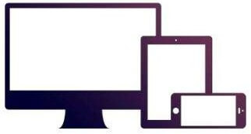

### History of Bootstrap

Bootstrap was developed by Mark Otto and Jacob Thornton at Twitter.It was released as an open source product in August 2011 on GitHub.

In June 2014 Bootstrap was the No.1 project on GitHub.

### Why use Bootstrap

Following are the main advantage of Bootstrap:

* It is very easy to use. Anybody having basic knowledge of HTML and CSS can use Bootstrap.
* It facilitates users to develop a responsive website.
* It is compatible on most of browsers like Chrome, Firefox, Internet Explorer, Safari and Opera etc.

### What is a responsive website

A website is called responsive website which can automatically adjust itself to look good on all devices, from smart phones to desktops etc.

### What Bootstrap package contains

**Scaffolding:** Bootstrap provides a basic structure with Grid System, link styles, and background.

**CSS:** Bootstrap comes with the feature of global CSS settings, fundamental HTML elements style and an advanced grid system.

**Components:** Bootstrap contains a lot of reusable components built to provide iconography, dropdowns, navigation, alerts, pop-overs, and much more.

**JavaScript Plugins:** Bootstrap also contains a lot of custom jQuery plugins. You can easily include them all, or one by one.

**Customize:** Bootstrap components are customizable and you can customize Bootstrap's components, LESS variables, and jQuery plugins to get your own style.

## What is Bootstrap 4?

Bootstrap is the newest and latest version of Bootstrap. It is the most popular HTML, CSS, JavaScript framework for developing responsive, mobile first websites.

## Bootstrap 3 vs. Bootstrap 4

Bootstrap 4 has some new components, faster stylesheet, more buttons, effects and more responsiveness.

Bootstrap 4 supports some the latest, stable releases of all major browsers and platforms.

### CHAPTER 3

WORK DETAILS

This project is based on Web Development . The project has been done on Atom and Netbeans

**ATOM**

Atom is a free and open-sourcetext and source code editor for macOS, Linux, and Microsoft Windows with support for plug-ins written in Node.js, and embedded Git Control, developed by GitHub.

Atom is a desktop application built using web technologies.

Most of the extending packages have free software licenses and are community-built and maintained.

Atom is based on Electron (formerly known as Atom Shell), a framework that enables cross-platform desktop applications using Chromium and Node.js.

It is written in CoffeeScript and Less.

It is fully customizable in HTML, CSS, and JavaScript

ATOM supports the following programming languages :-

* BASH
* C
* C++
* COBALT
* HTML
* JAVA
* JAVASCRIPT
* CSS
* PHP
* JSON
* SQL
* C#
* OBJECTIVE C
* XML

ATOM SUPPORTS THE FOLLOWING FEATURES :-

Cross-platform editing

Atom works across operating systems. Use it on OS X, Windows, or Linux.

Built-in package manager

Search for and install new packages or create your own right from Atom.

Smart autocompletion

Atom helps you write code faster with a smart and flexible autocomplete.

File system browser

Easily browse and open a single file, a whole project, or multiple projects in one window.

Multiple panes

Split your Atom interface into multiple panes to compare and edit code across files.

Find and replace

Find, preview, and replace text as you type in a file or across all your projects.

**NETBEANS**

It is an open-source integrated development environment (IDE) for developing with Java, PHP, C++, and other programming languages. NetBeans is also referred to as a platform of modular components used for developing Java desktop applications.

NetBeans is coded in Java and runs on most operating systems with a Java Virtual Machine (JVM), including Solaris, Mac OS, and Linux.

NetBeans manages the following platform features and components:

* User settings
* Windows (placement, appearance, etc.)
* NetBeans Visual Library
* Storage
* Integrated development tools
* Framework wizard

NetBeans uses components, also known as modules, to enable software development. NetBeans dynamically installs modules and allows users to download updated features and digitally authenticated upgrades.

NetBeans IDE modules include NetBeans Profiler, a Graphical User Interface (GUI) design tool, and NetBeans JavaScript Editor.

NetBeans framework reusability simplifies Java Swing desktop application development, which provides platform extension capabilities to third-party developers.

Oracle Database can be registered and accessed directly from the IDE. The IDE supports both OCI and Thin JDBC connections to the Oracle Database. Full data access features are provided out of the box, such as the ability to read, create, update and delete data directly within the IDE, supported by a feature rich SQL Editor

**CHAPTER 4**

STEP WISE WORKING FOR WEBSITE

1. Writing Html

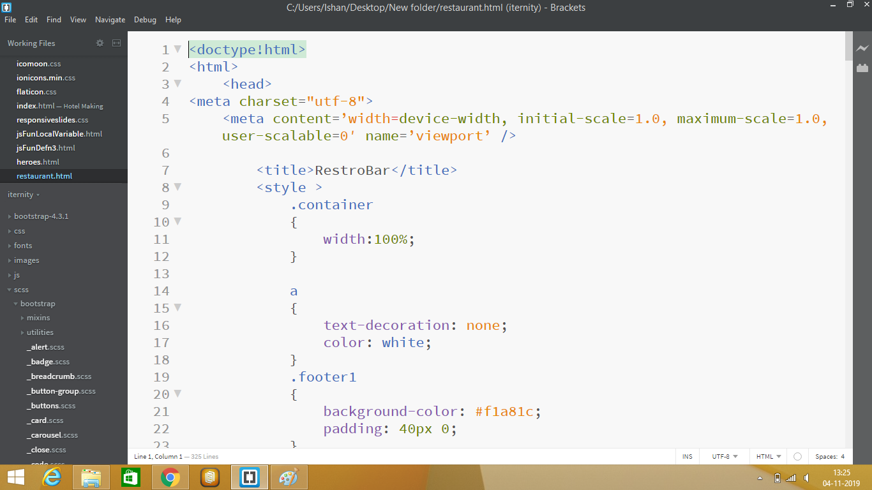

2.Writing CSS

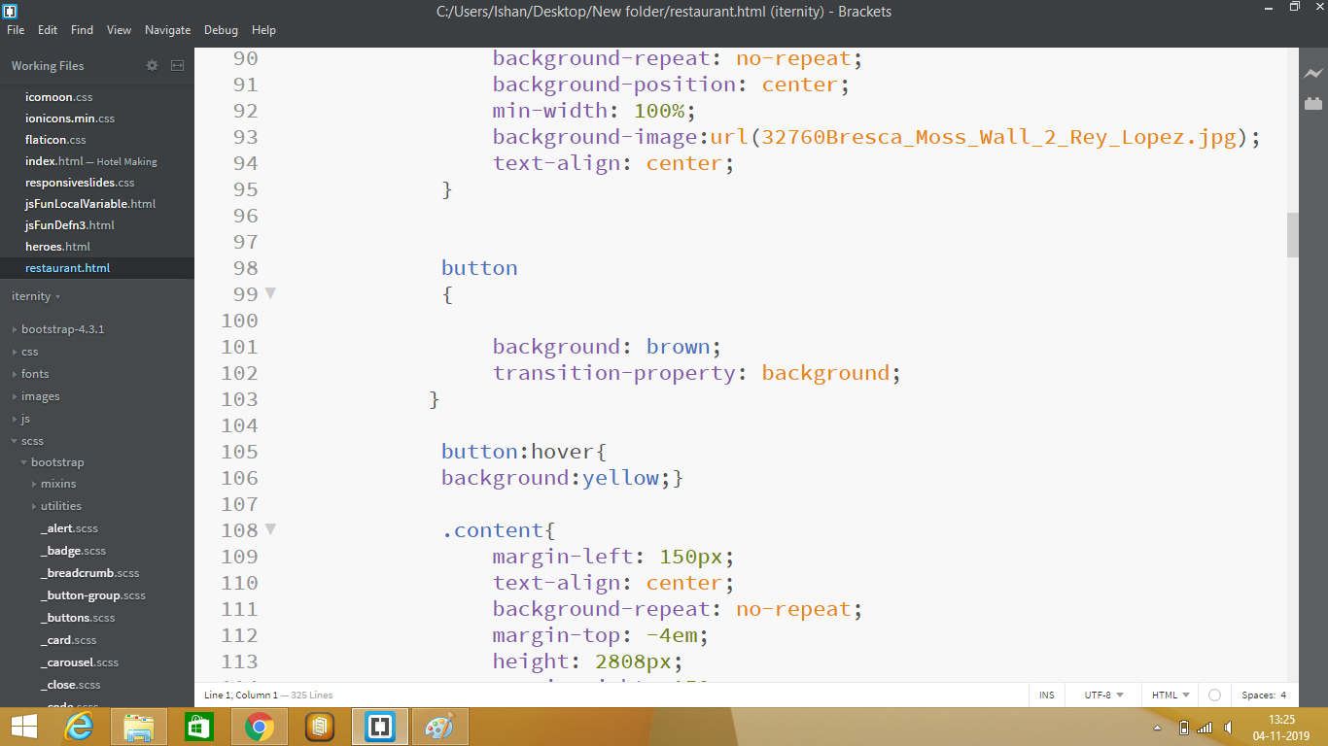

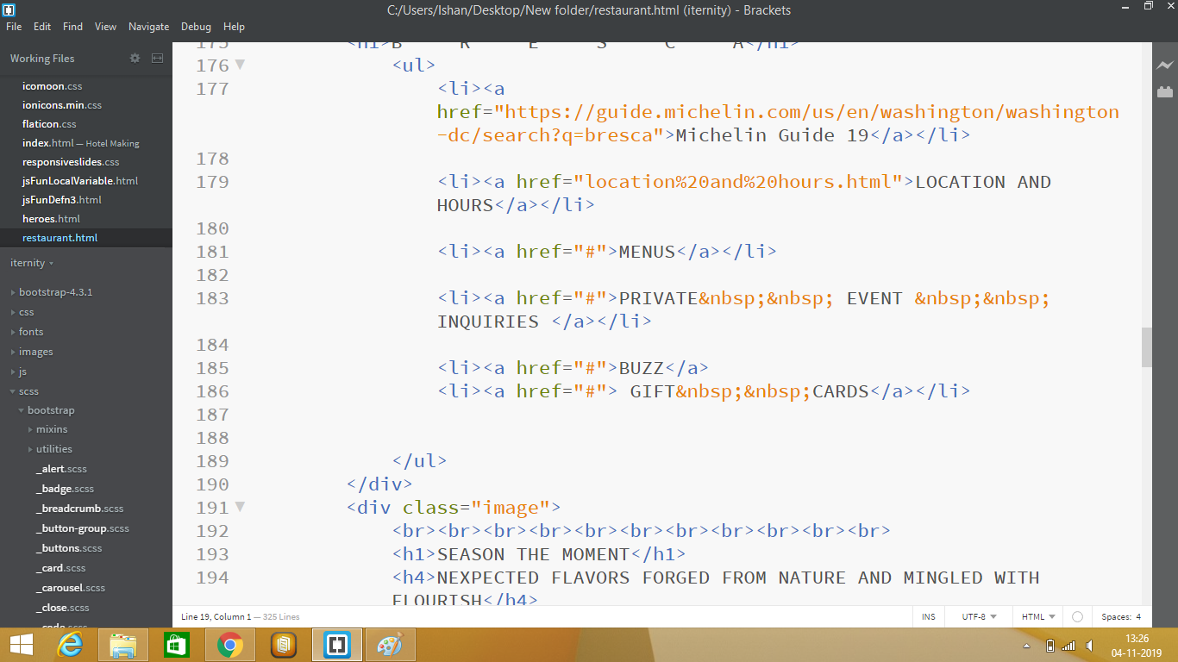

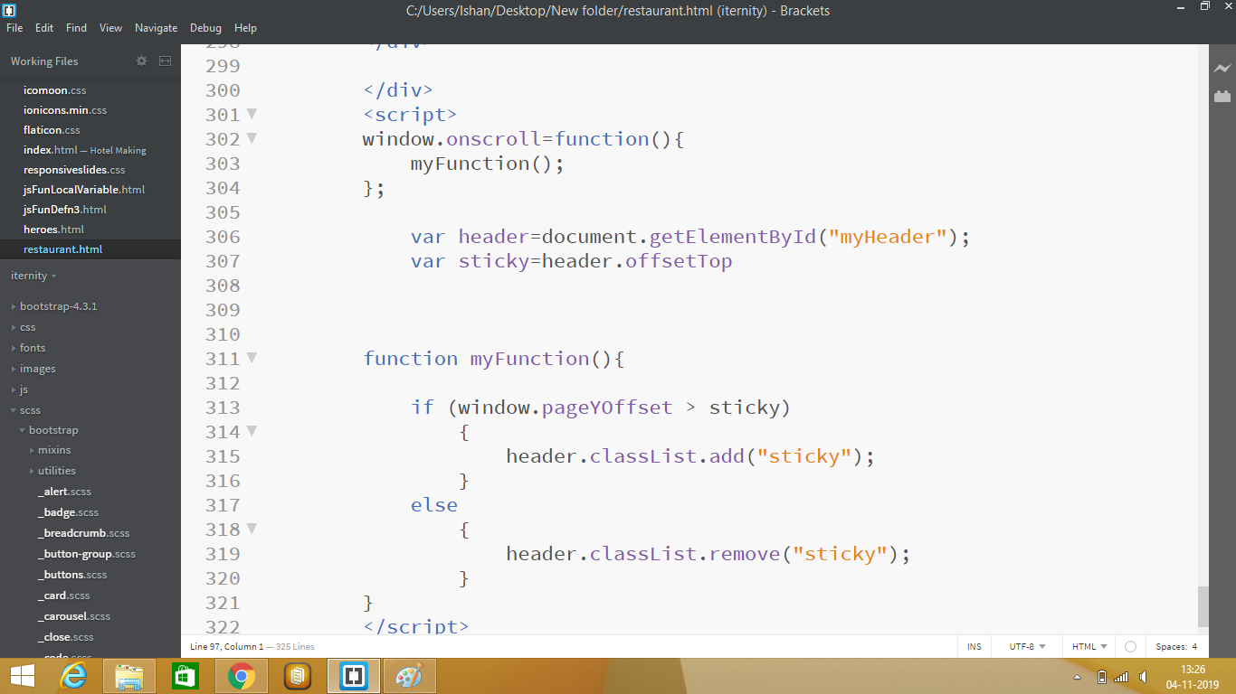

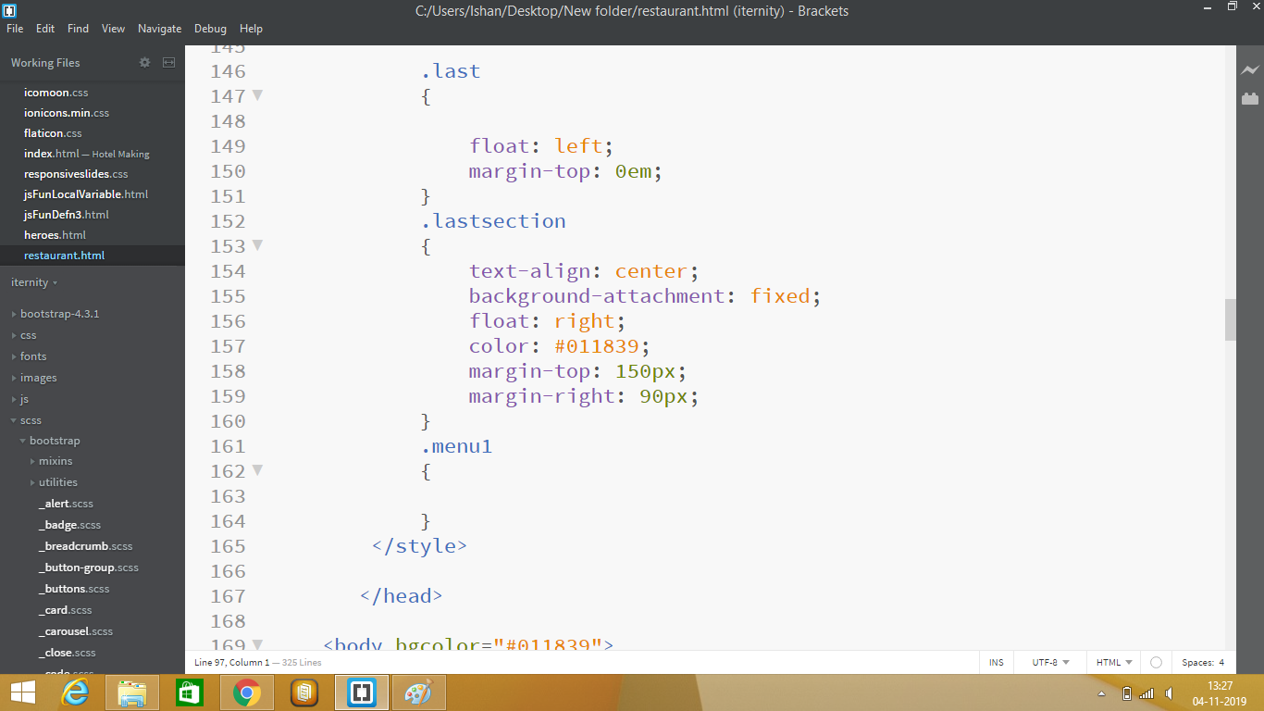

3. Writing Javascript and J query

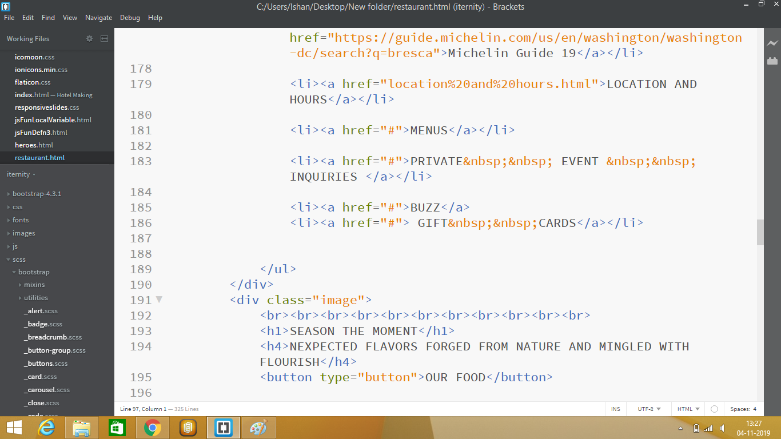

4.JDBC code for connectivity

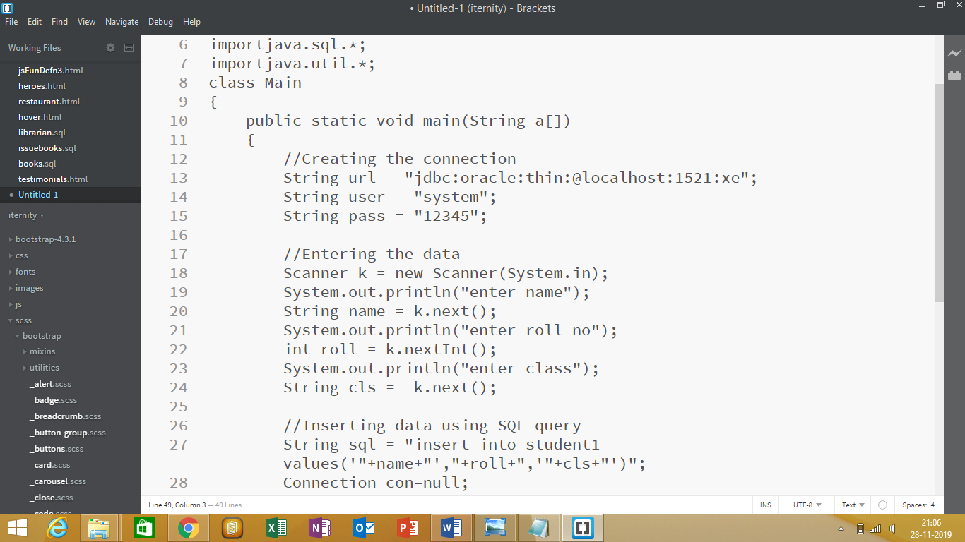

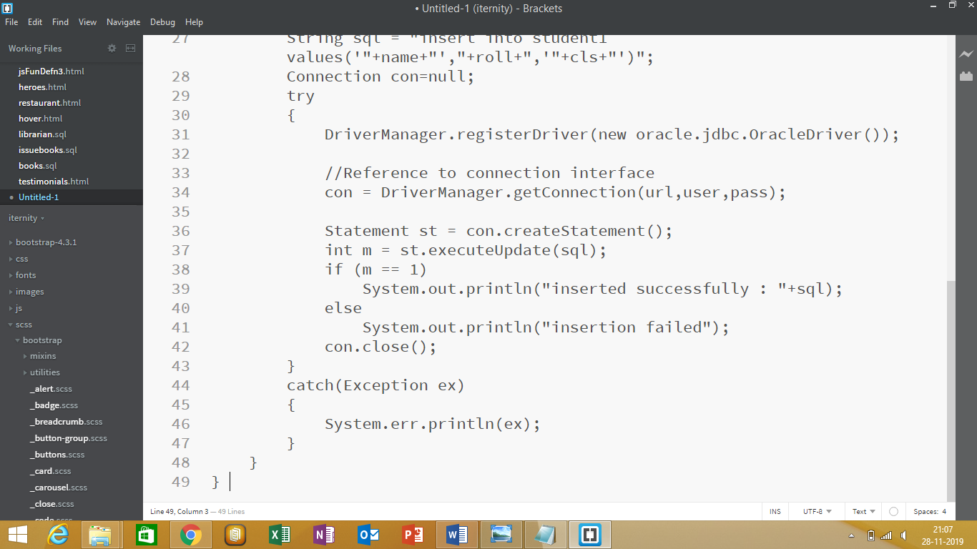

**OUTPUTS**

# WEBSITE:

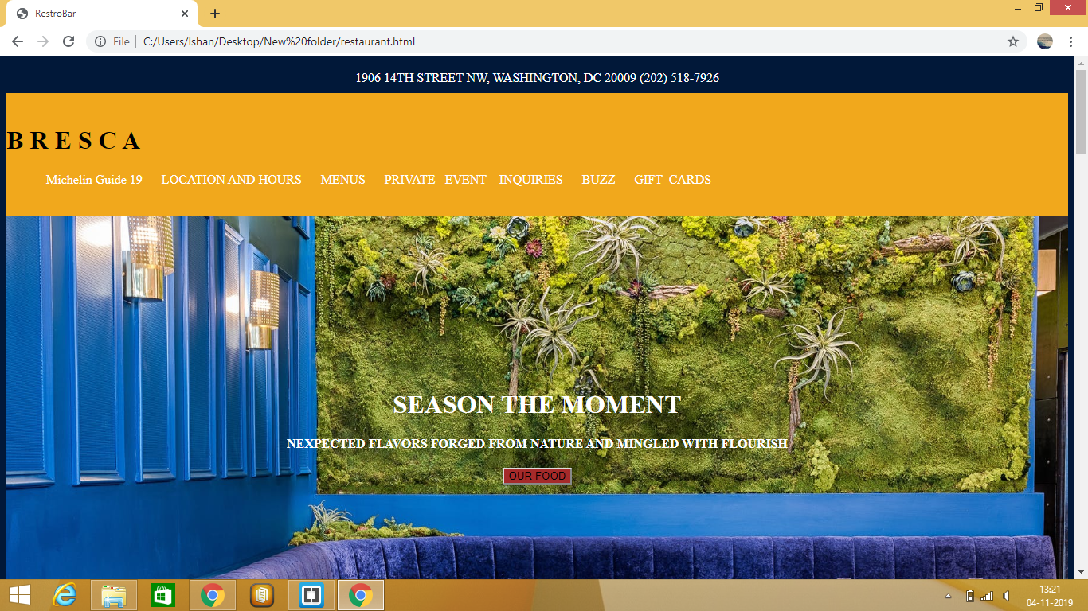

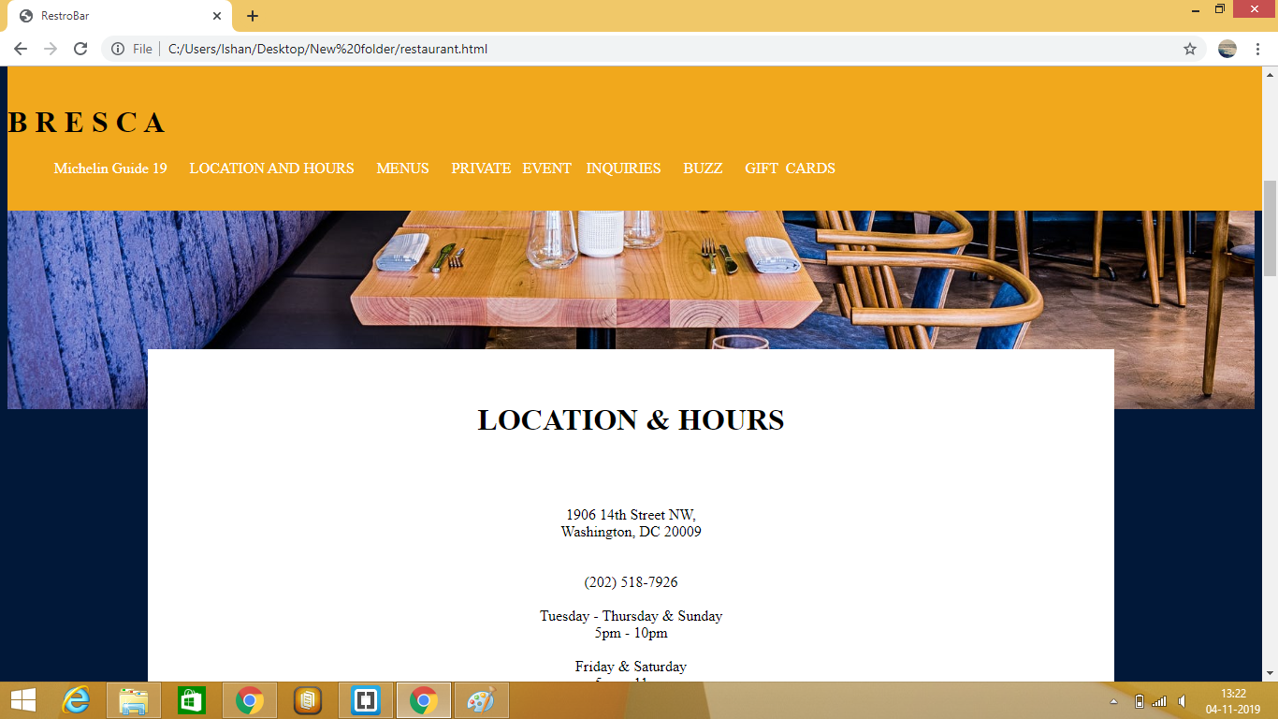

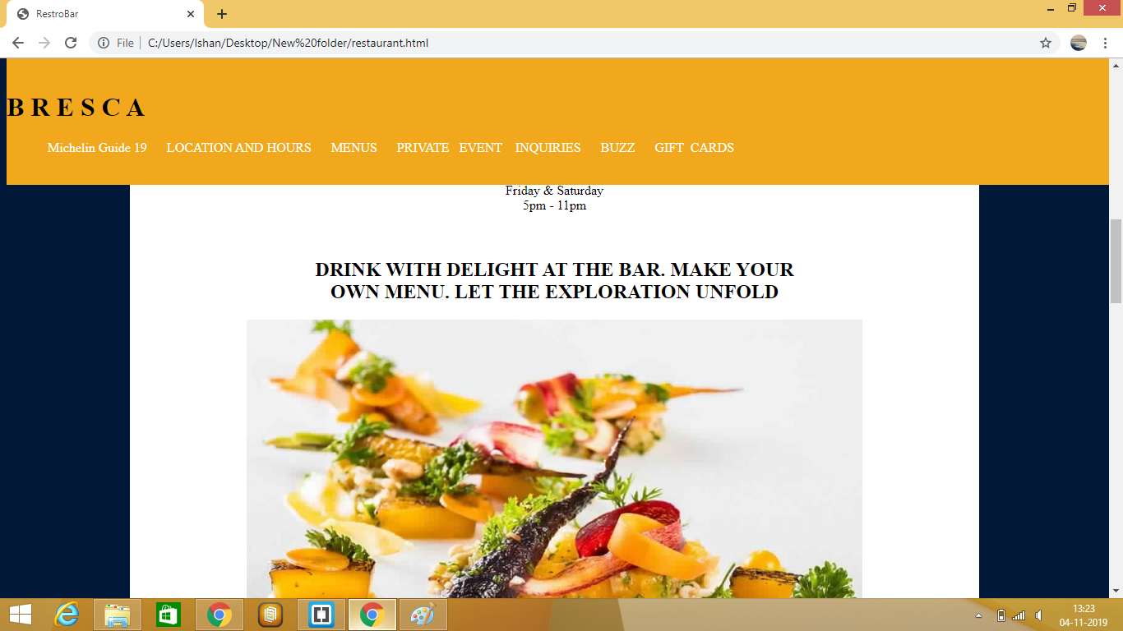

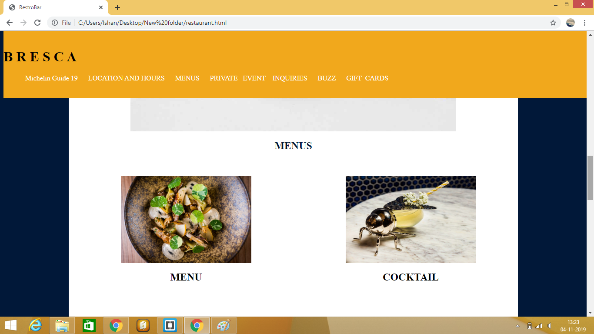

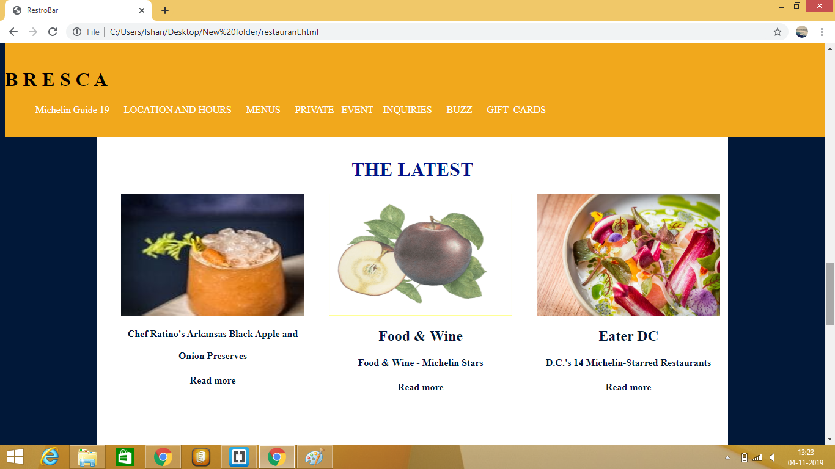

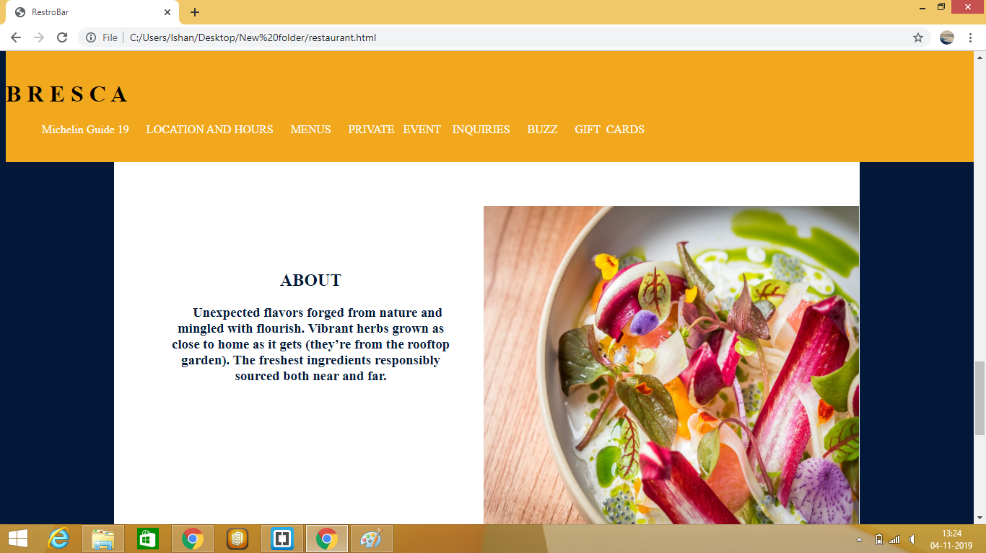

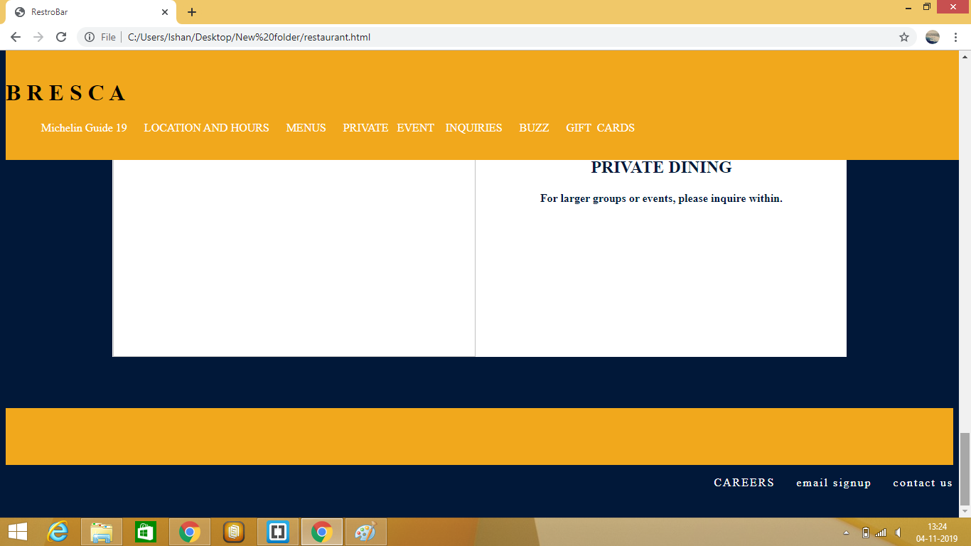

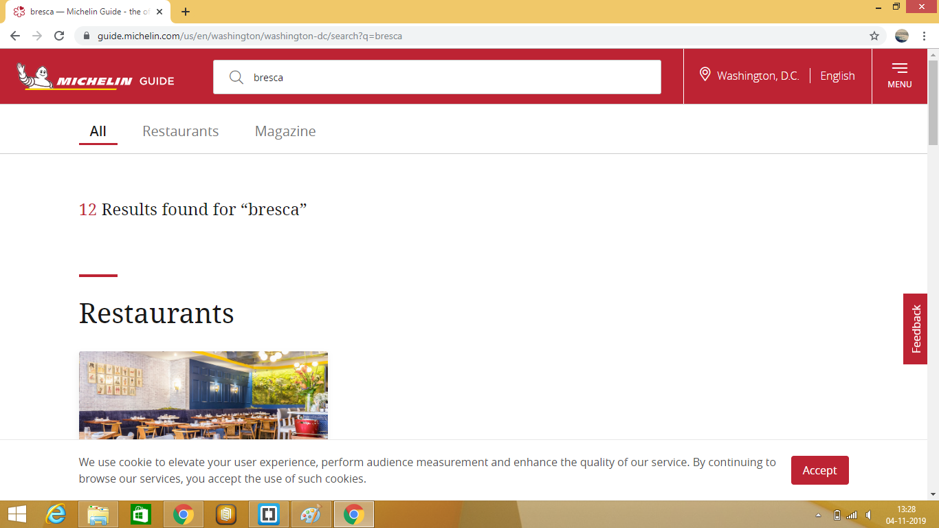

# FUTURE AND SCOPE

# FUTURE SCOPE OF THE PROJECT

# For any business, a website matters more than anything, when it comes to reaching out to customers online. A website is the representation of the business online. These days, every business realizes the need for having a website and are putting in efforts to design and develop the best site for taking their products or services online. This is where we can see a great deal of scope for web development and design.

# With the tremendous progress in the launch of websites, people who can create exemplary designs and platforms for their online presence is what businesses are searching for. Web developers and designers are bringing in all the best of their technical expertise and skills to develop and unique design websites that are and capable of pulling the crowd.

# 

# This project is an example of a website. Several modifications can be done in it to make it more attractive and dynamic.This website is a responsive website and people can use it in mobile and laptops withouth the distortion of the website.

CONCLUSION

* + The project on Web Development has finally been completed successfully .
  + We have gain knowledge about html, css, javascript, jquery, bootstrap, core java, JDBC .
  + The objectives of the project is website and its connectivity that were met .
  + We have finally gained knowledge about Web Development.

References

Online:

* + Stack overflow
  + Quora
  + W3schools

Offline:

* + Aptech Janakpuri

**Certficate(s)**

* Internship at MCM INFOTECH Solutions

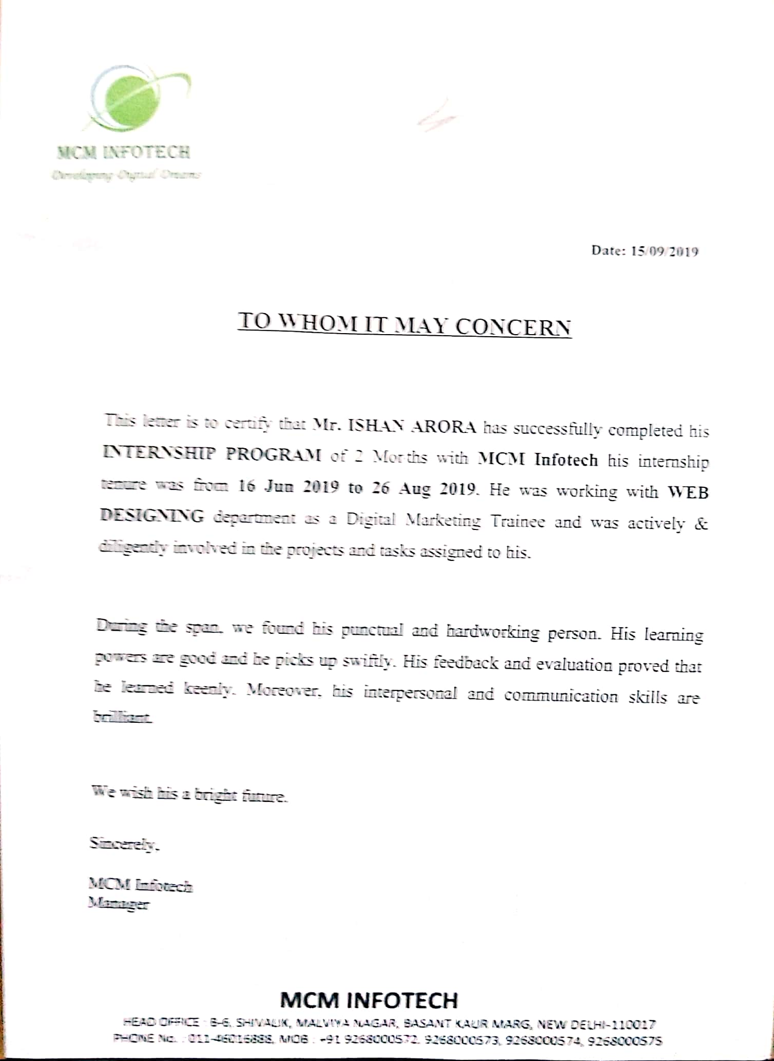

* Web development at Aptech International

***Thank You !***